Jose Martinez  
9/12/2018

**SENIOR PROJECT PROPOSAL**

Emergency Resource Allocation (ERA) Website

Table of Contents

I. SUMMARY 2

II. INTRODUCTION 3

III. USE CASES 4

IV. NEEDS/PROBLEMS5

V. GOALS/OBJECTIVES5

V. TIMETABLE 6

1. Summary

The overall goal of the Emergency Resource Allocation (ERA) Website is to create a functioning website that can help gather, organize, and display resource data in the event of a disaster. The ERA website should present gathered civilian information clearly and indicate which affected areas need which resources as well as the quantities needed. The intended effect is that this will help speed up the reaction and recovery time of an area following a disaster level event (such as a hurricane). With a clear view of what materials are being demanded in regions, resources can be allocated where they are needed the most, thus reducing surplus supplies and prioritizing help where it imperative.

Government agencies will be able to login and create a new web page for their disaster event and set up which resources they have available. They will also be able to allocate those resources to whichever region they want, will not be able to allocate more than they have and the database should update accordingly.

Donating users, such as charities, will be able to contribute resources. Donating users will not be able to allocate resources, their donations will be added to an overall total of available resources. They can view which resources are needed and how much of a given resource is already available.

Civilian users will be able to log in and report damage such as fires or flooding in their area. They will be shown available resources and report what they need and how much they need (limits will be set on how much an individual can request). They will also have the option to create a new resource and request that. Their resource will be added to the database and will be available for viewing by other users. These users will be organized by region, where their homes are.

1. Introduction

Natural disasters happen more frequently than most people think. This past year alone severe flooding troubled many in Texas while harsh wildfires distressed others in California. In the wake of these disasters there has been chaos in providing help to those affected. A contributor to this chaos is that it is often unclear which areas need what resources the most. An Emergency Resource Allocation (ERA) Website that can organize resource demands from various areas and present them in a clear manner would greatly aid the rescue efforts of the people trying to help the victims of these disasters. Currently the Federal Emergency Management Agency has set up [www.disasterassistance.gov](http://www.disasterassistance.gov) a website where people can seek assistance in finding shelter during a natural disaster. However, this website does not have a way for people to report what resources they need, whether their area needs specific items or special care. The ERA Website will allow civilians to report first hand what resources they need. These reports will then be arranged by region and be available for viewing by any government officials in charge of resource allocation. The resource orders will also be available for viewing by charitable corporations when they sign up.

The database for the website will have different regions for each of the areas affected. This information will be obtained from government and civilian users, a fully developed version of this project would attempt to take this data from the some other government document, a census program or city planning document. Some of the attributes the website will manage include the number of people injured or needing medical assistance, whether or not an area has water, food, and electricity. Other attributes would be the status of an area such as whether or not it is flooded, has large amounts of fires, and the number of buildings or homes destroyed. The number of homes destroyed could be calculated by people logging into a website, typing in their address, and indicating whether their home was destroyed. A fully integrated version of this project could have phone companies submit information regarding which of their cell towers were affected, since this would indicate a lack of communication available in a given area. The website will have three types of users: government level users, corporate level users, and civilian users.

The website will be able to display what resources are available. Possible resources would be the number of volunteers, number of doctors, amount of food and water, available rescue vehicles. By organizing all the data, the recovery time for a given region could be significantly lowered.

1. Use Cases

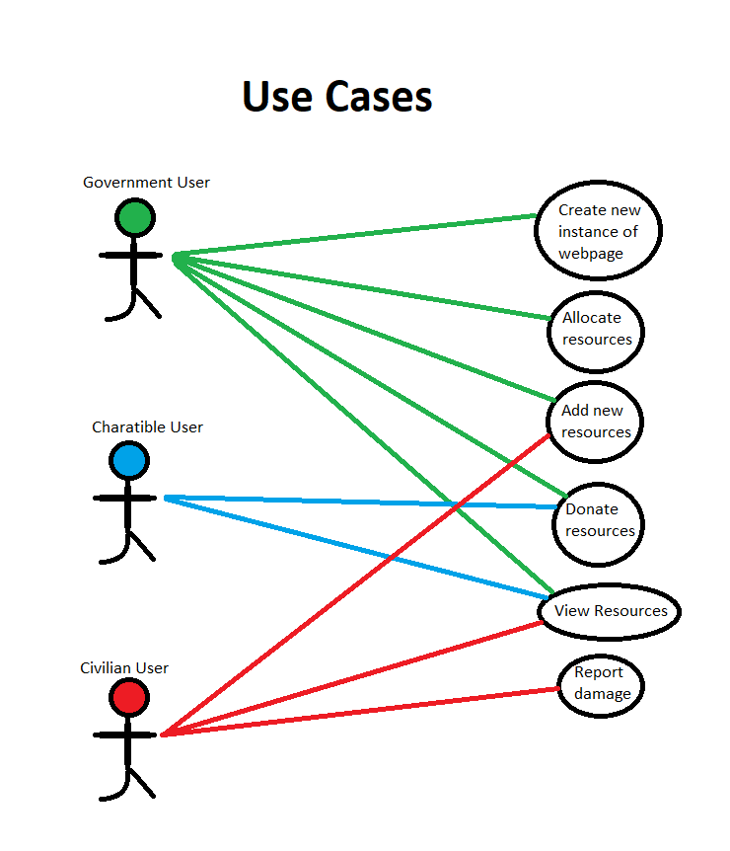

1. Needs/Problems Addressed
2. When a natural disaster strikes there is a lot of confusion and chaos.
3. Getting help to where it is needed can be problematic if no one knows which regions need what resources.
4. Misallocation of resources can lead to loss of life, people may not get the help they need in time.
5. Misallocation of resources can lead to inefficient resource dispersal, one region can have a surplus of a particular resource while another region is desperately lacking it.
6. Current go-to website for natural disasters is FEMA’s disasterassistance.gov and it primarily deals with finding shelter for families not for helping organize disaster information.
7. Goals/Objectives
8. Efficiently organize data and display it effectively (clearly).
9. Government users and donating users should be able to clearly see which regions need which resources the most.
10. Government and donating users should be able to clearly see how much of each resource is currently available.
11. Optimizing the allocation of resources can aid recovery time, reduce loss of life, and minimize spending.
12. Timetable

Provide detailed information on the expected timetable for the project. Break the project into phases, and provide a schedule for each phase.

|  |  |
| --- | --- |
| **ACTIVITY** | **IMPLEMENTATION TIME** |
| 1. Design web page and database. Determine desired features and functions; how many pages and what they should do. Also number of and types of users and their respective privileges. | Sept 12  -  -  Sept 21 |
| Begin implementation of web page side of project  -  Have rough draft “Welcome” page done | Sept. 22  -  Sept. 27 |
| Begin “Login” and user “Sign-up” pages  -  Have those pages done | Sept. 28  -  Oct. 3 |
| Login and user database testing | Oct. 4  -  Oct. 7 |
| Create a “View Resources” page and set up corresponding database  -  Have page complete | Oct. 8  -  -  Oct. 13 |
| Set up “Donations” web page  -  Have page complete | Oct. 14  -  Oct. 19 |
| Set up “Regions” web page and set up corresponding database  -  Have page complete | Oct. 20  -  -  Oct. 25 |
| Begin improving appearance of rough draft webpages  -  Finish aesthetics | Oct. 26  -  Oct. 31 |
| Add any other features | Nov. 1  - |

|  |  |  |  |
| --- | --- | --- | --- |
|  |  |  |  |
| [Name], Project Creator  Date: _____________ |  | [Name], Project Advisor  Date: _____________ |  |